To: Dr. Trevas

From: Davis Geniza, Alec Boyce, Ryan Fortier, Oscar Nunez, Zhiyu Wang

Date: September 25, 2020

Subject: Implementation memo

This memo regards the Excavator Team’s progress regarding their design and progress towards creating a remote operated, electrically powered, mini excavator. Discussion regarding manufacturing, design changes, future implementation, future manufacturing, scheduling, and current bill of materials sum up the contents of this memo.

# Implementation (Zhiyu)

This part will focus on the implementation part of the excavator team. This includes how the excavator team will manufacture project products in the future. Compared with the previous design, what are the improvements in the current design? What are the improvements in the performance of the excavator products and the benefits these improvements have brought to the excavator team? In addition, this section also includes a detailed discussion of the changes to the excavator subsystem and components.

## Manufacturing (Oscar)

The current manufacturing plan for our teams Remote Operated Excavator, are subdivided into a few categories. These categories are broken down further and are headed by one of the members of the team and help is provided to each member. These categories include a kinematic model analysis, static and dynamic force analysis, Arduino code creation and implementation for the remote-control portion of the design, Hydraulic system and component analysis, as well as body design and implementation. With all of these categories, logistics are key to the overall success of the design. At the moment the analysis and design categories are near completion and the biggest challenge facing our team will be the assembly of the excavator itself. Our team will do most of the work and will consist of welding the parts together and mounting the components on the body as we assemble the excavator. Some of the challenges include low welding skills amongst our team as well as budget constraints. In terms of actual manufacturing processes, the biggest one is welding.

## Design Changes (Davis)

The biggest design change to the excavator has been transitioning from a design without a rotating arm to one. The original design utilized the motorized wheels of the excavator to turn and dispose of dirt, while the new design places the arm on a rotating platform. Implementing this design required new CAD modeling. Other changes included redesign of the excavator’s body, which was done in order to fit the hydraulic system. Applying these changes physically have been deterred by necessary quarantining of team members.

### Design Iteration 1: Change in Arm Rotation Capabilities and Body (Alec)

The original design consisted of an excavator arm that did not have the ability to rotate to dump dirt. After speculation with the team and the client the team came to the conclusion that the arm would be best suited to rotate 90 degrees to allow the excavator to dump dirt without having to move locations. Another design change that was implemented was a larger body size to accommodate the large hydraulic system that the team acquired form NAU campus. The original design was sized for the components we had measurements for, the hydraulic system was recently acquired and accounted for in the body redesign.

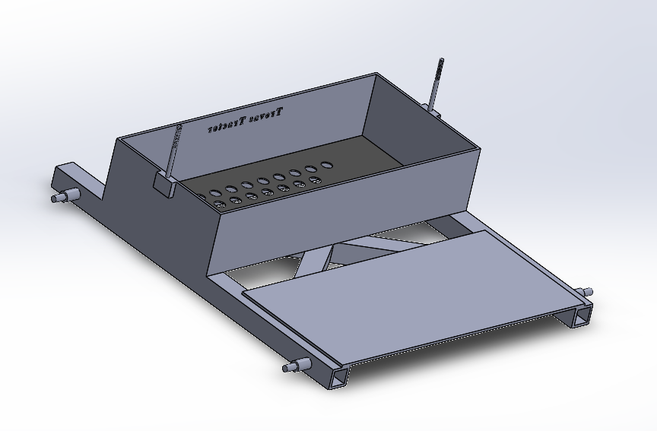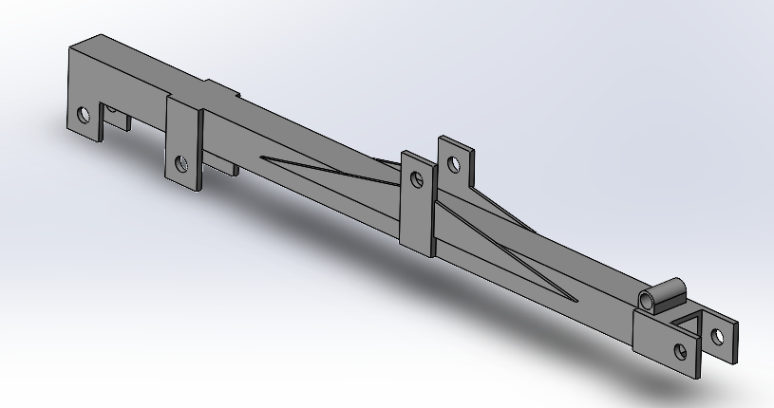

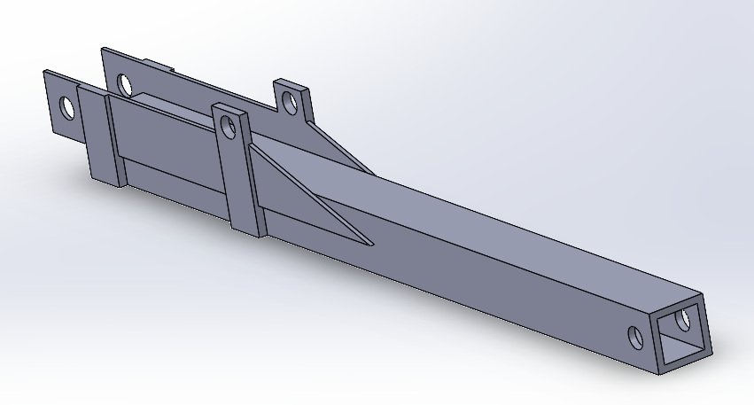

**Figure 1:** CAD Changes

# Future Implementation (Davis)

The future of the project is largely dependent on how much the pandemic further affects the progress of the group. Unfortunately, the team desired to have all parts purchased and delivered by this point in the semester, but due to the pandemic the department in charge of budgeting had understandable setbacks with respect to providing budgets to capstone teams. Although a budget has now been provided to the team, it is uncertain whether the team will have the necessary time to purchase and construct all the parts for the excavator. Attributing to this uncertainty is the pandemic itself, as multiple members were required to quarantine as they awaited COVID test results which also prevented physically meetings of the team and assessment of the hydraulic system. Regardless of the adversity the team has and will face, there are still planned implementations of design and manufacturing to be met. This includes manufacturing of the base and arm of the excavator, creation of the hydraulic and electric system, and design of the electrical schematic. Modeling an animation of the entire excavator design is also planned, as well as further calculations regarding the battery system and digging forces.

## Further Manufacturing and Design (Ryan)

The manufacturing plans for the design require a cutting tool, a welder, and a drill. Due to the high cost of materials, the team will use a drill to create holes for the pin joints and motor mounts instead of having those parts machined. The team is also confident that the members can make clean and accurate cuts themselves. After each plate and tube has been properly cut, the team plans to use a flux welder to join the parts together at one team members' home. Two members of the team have become proficient welders and feel comfortable with the task. The team is planning to use hitch pins to join the boom, and dipper together, and bolts to attach the bucket to the dipper. At this moment the team is not certain of the sizes necessary for the small hardware.

## Schedule Breakdown (Davis)

**Figure 2** below shows a color schematic of the planned schedule for the Fall 2020 semester. Initial modeling has been completed, with its respective assembly but due to design changes further modeling is still planned to be completed by mid-October. Changes to the initial modeling include the design change of adding rotational movement of the excavator arm. This change required additional CAD of the body of the excavator, creating a platform that can be rotated. Addition of the hydraulic system and electrical system will also be included in the CAD modeling. Furthermore, creating an electrical schematic has been added to the schedule. This schedule accommodates all possibilities of deliverables, whether building the entire design, subsystems of the design, and a complete design-based iteration for this final semester of capstone.

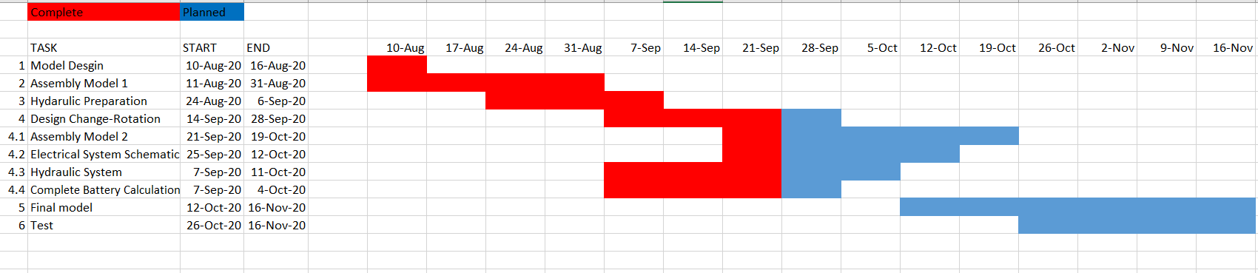

**Figure 2**: Semester Schedule

## Budget breakdown (Ryan)

Based on **Figure 3**, the total cost of materials would total $2769.46. As shown in the figure, some components are at zero cost because the team already has these parts free of charge from the engineering department at NAU. Although the design requires three hydraulic rams, the cost can potentially be lowered if the rams provided have a suitable stroke length. The budget liaison has chosen the cheapest option available, without compromising the strength of the design. The lengths of materials were dictated by precut lengths available for purchase, which allows for error without a need to purchase more materials, in turn lowering cost.

|  |  |  |  |  |  |  |  |  |  |  |  |  |  |  |  |  |  |  |  |  |  |  |  |  |  |  |  |  |  |  |  |  |  |  |  |  |  |  |  |  |  |  |  |  |  |  |  |  |  |  |  |  |  |  |  |  |  |  |  |  |  |  |  |  |  |  |  |  |  |  |
| --- | --- | --- | --- | --- | --- | --- | --- | --- | --- | --- | --- | --- | --- | --- | --- | --- | --- | --- | --- | --- | --- | --- | --- | --- | --- | --- | --- | --- | --- | --- | --- | --- | --- | --- | --- | --- | --- | --- | --- | --- | --- | --- | --- | --- | --- | --- | --- | --- | --- | --- | --- | --- | --- | --- | --- | --- | --- | --- | --- | --- | --- | --- | --- | --- | --- | --- | --- | --- | --- | --- |
| |  |  |  |  |  | | --- | --- | --- | --- | --- | | **Bill of Materials** |  |  |  |  | |  | Item | Quantity | Cost ($) | Total Cost ($) | | 1 | 2x2 steel square tubing | 16 ft | 71.66 | 71.66 | | 2 | Arduino Kit | 1 | 35 | 35 | | 3 | Hydraulic RAM | 3 | 143 | 429 | | 4 | Hydraulic Pump | 1 | 0 | 0 | | 5 | Wheels | 4 | 6.99 | 27.96 | | 6 | Batteries | 4 | 89.97 | 359.88 | | 7 | Power Inverter | 1 | 323 | 323 | | 8 | Electric Motor | 2 | 162.99 | 325.98 | | 9 | .125 inch steel plate | 1 | 31 | 31 | | 10 | Hydraulic Manifold | 1 | 1 | 1090 | | 11 | 1/2" Hose | 24 ft | 75.98 | 75.98 | |  |  |  | TOTAL | 2769.46 | |

**Figure 3***:* Bill of Materials